SET-8 — Employee Performance Analysis
AIM
To analyze employee performance data and visualize employee performance trend, department distribution, and performance information using R programming.
ALGORITHM
- Start RStudio.
- Create the Employee Performance dataset.
- Create a line chart to visualize employee performance over years of service.
- Create a bar chart showing the distribution of employees across departments.
- Display the employee performance data in a table.
- Add suitable titles and axis labels.
- Display the output.
- Stop.
R CODE
employee<-data.frame(Employee_ID=c(1,2,3),Department=c("Sales","HR","Marketing"),Years_of_Service=c(5,3,7),Performance_Score=c(85,92,78))
plot(employee$Years_of_Service,employee$Performance_Score,type="o",main="Employee Performance Trend",xlab="Years of Service",ylab="Performance Score")
dept<-table(employee$Department)
barplot(dept,main="Distribution of Employees by Department",xlab="Department",ylab="Number of Employees")
employee
OUTPUT
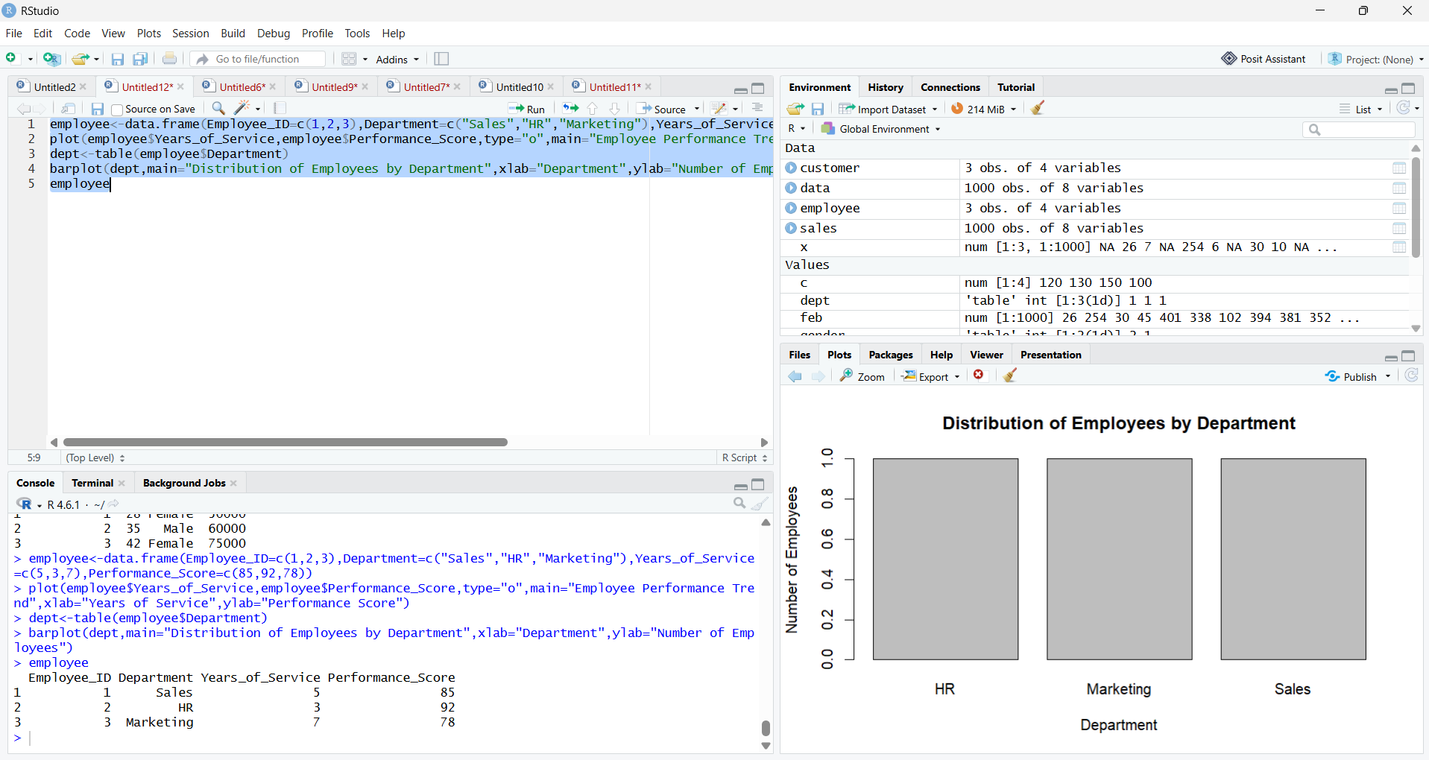RESULT
Thus, the Employee Performance data was successfully analyzed using R programming. The line chart, bar chart, and employee performance table were successfully created.

